Directions: For each of the questions below, I would like you to provide a thoughtful and original written response. I am looking for your consideration of each topic, based on your academic and/or industry experiences, and your experience with the class. I would encourage you to use at least one or two good (i.e. not Wikipedia) literature citations to support your answers, from the web, papers, or books. A well-presented answer will be about one page of a few paragraphs, single spaced at normal font sizes. Please do not paste in any text from another source without marking it as quoted and providing the citation for where it came from. Please recall that the work for these submissions must be yours and only yours; do not work with other people to craft your answers. Turn in your work as a PDF.

1. I use the V diagram a lot in lectures (<https://insights.sei.cmu.edu/sei_blog/2013/11/using-v-models-for-testing.html>).

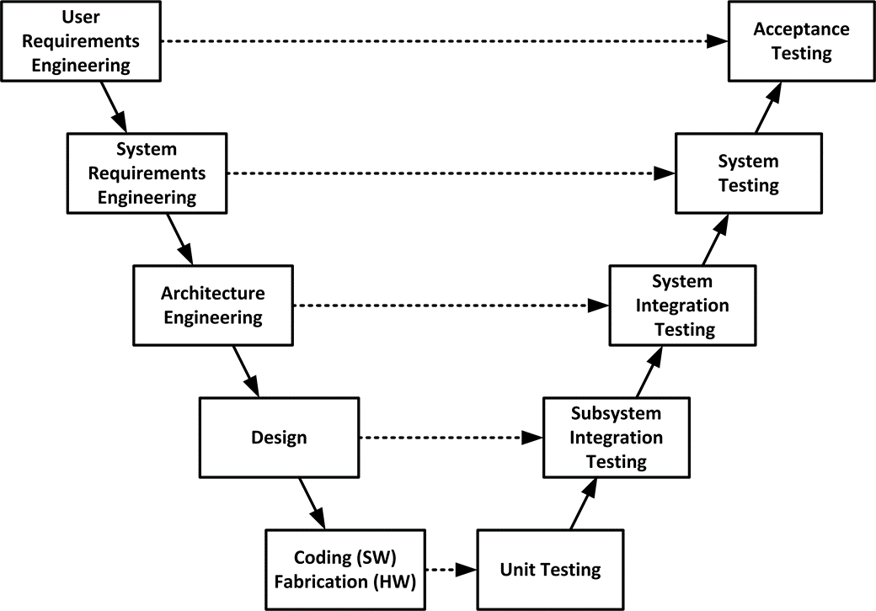

I use it to talk about three areas primarily - progressive elaboration of designs and requirements, waterfall engineering processes, and the importance of testing and verifying requirements in development. Which of these three areas feels the most important in your experience with software projects? What benefits, issues, and practices do you feel are important to that specific area?

1. In our kickoff of our projects, we worked with several planning tools: project charter, project brief, WBS, requirements. There were also some tools for planning we did not use: project plans, Gantt charts, etc. Which one project management tool do you feel is the best contributor to establishing the start of a project? What benefits, issues, and practices for that tool do you think are important to be aware of?
2. We will be spending most of the two semesters of our software work using Agile methods for project management, control, and monitoring. We have started a Scrum process that we will use through the middle of the second semester, and then we will shift to Kanban for the tail end of the next semester – so you can experience both. How do you feel about the effectiveness of Agile methods, either in general, or a particular methods like Scrum or Kanban? What benefits, issues, and practices for the method do you feel are most important to consider for keeping the method working?